Step 1: Run importsm

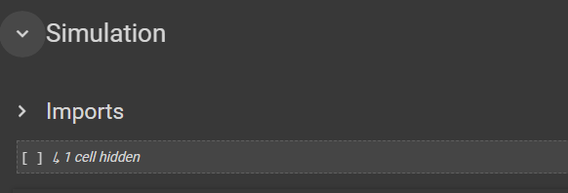

Step 2: Specify ratio and City

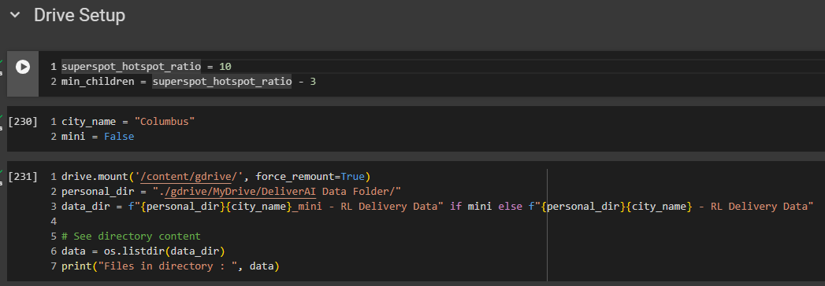

Step 3: Load data, create classes and functions

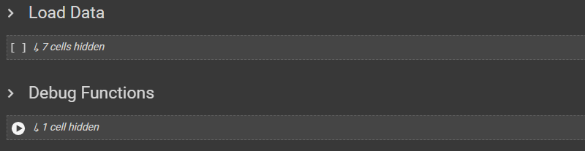

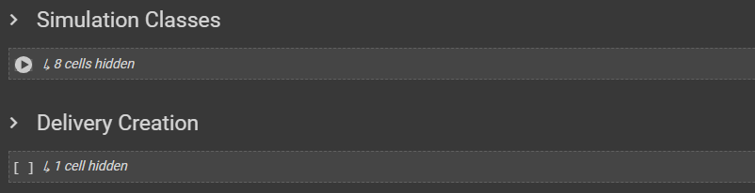

Step 4: Create variables for base delivery set

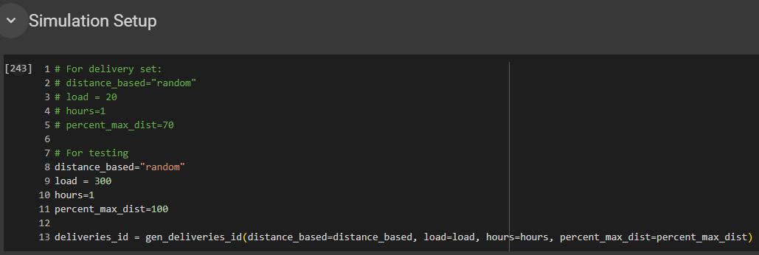

**Important: SKIP THE CODE BLOCK BELOW UNLESS DELIVERY SET DOES NOT EXIST**



Step 5: Compute threshold Percentage

Step 5.1: Load delivery set, make sure matrix data and time limits are correct

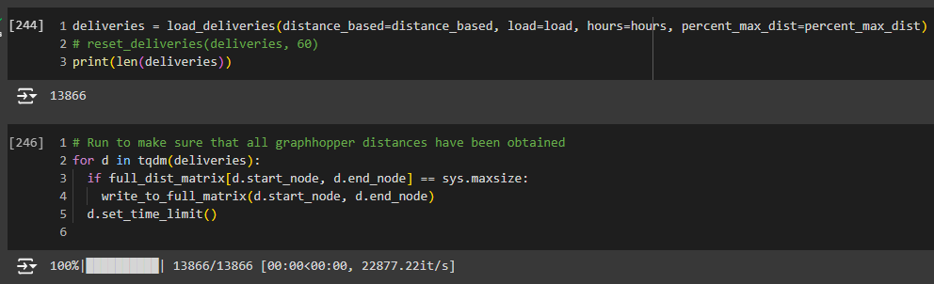

(Optional) Observe distribution of time limits

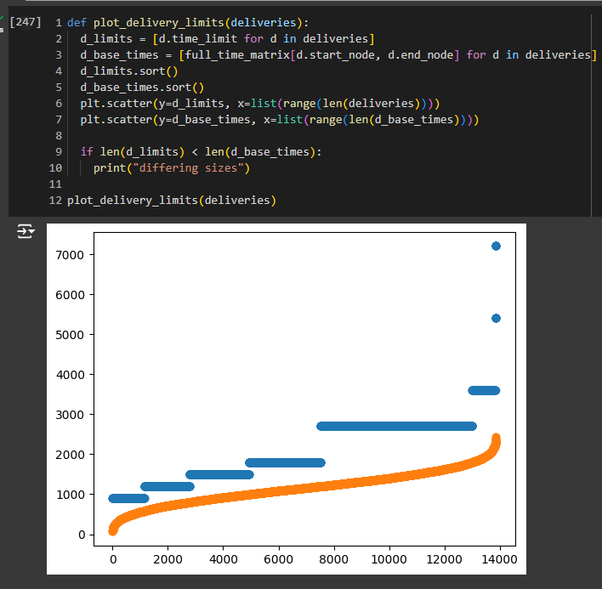

Step 5.2: Get Threshold Percentage

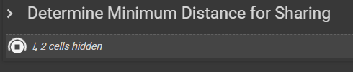

Note: Once graph is done generating, record the provided percentage in [Variable Combinations](https://docs.google.com/spreadsheets/d/17JAFaahG1gZ_C45X5_xIexmCkbB2RfyYEpFWfhxLqCA/edit?gid=0#gid=0)

Step 6: Run the simulation

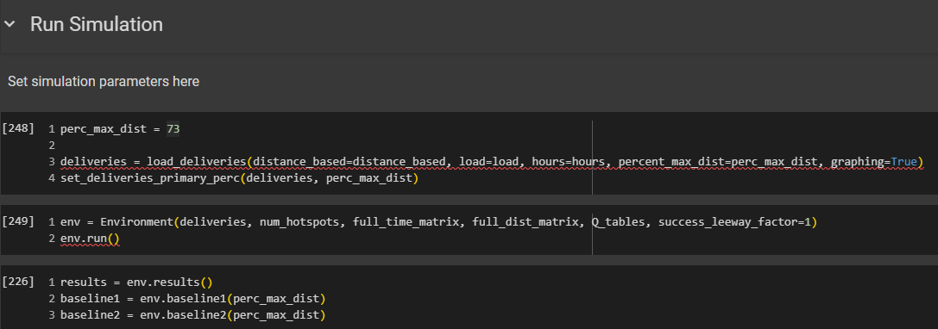

Note: Make sure to specify *prec_max_dist* as observed in the previous step

(Optional) Print results and check

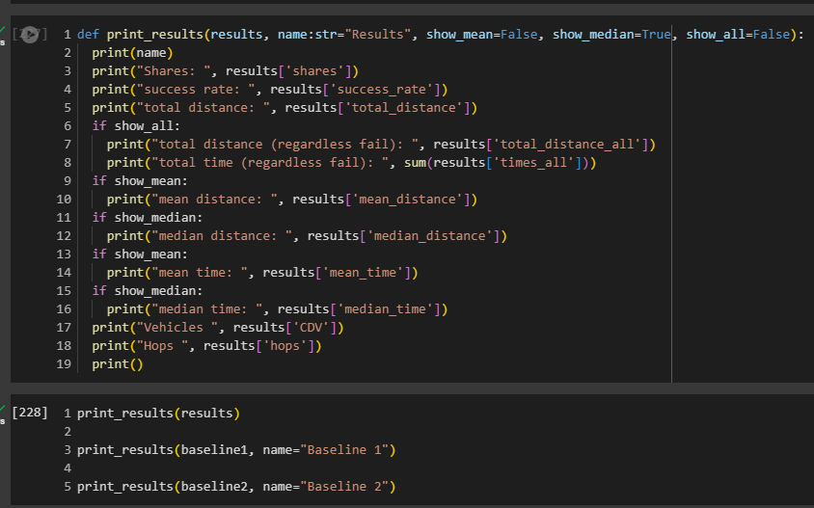

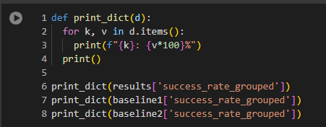

Step 7: Save results to file

